Auso Call Hub — WebRTC Phone Requirements
1. Core architecture
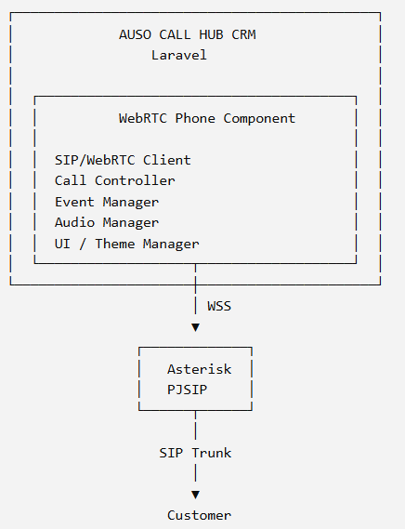
For the first production version, I would use SIP.js or a similar modern SIP/WebRTC library rather than building SIP signaling from scratch. SIP.js specifically supports Asterisk and browser WebRTC, including hold and transfers.

2. Automatic registration
This is one of your most important requirements.
Agent login
Agent logs into Auso Call Hub
↓
Laravel authenticates agent
↓
Laravel gets SIP credentials
↓
WebRTC Phone initializes
↓
Connect WSS
↓
SIP REGISTER
↓
Asterisk
↓
Registered
The agent should not manually enter SIP username/password.
For example, Laravel could provide:
{
"extension": "2002",
"sip_domain": "pbx.ausoworld.com",
"ws_url": "wss://pbx.ausoworld.com:8089/ws",
"password": "clear text password"
}
Then:
phone.connect();
phone.register();
SIP.js supports connecting and registering programmatically.

Security recommendation
Don't expose the permanent SIP password in the HTML page.
Use a Laravel-generated short-lived credential/token and have a backend service provision or authorize the SIP session.

3. Required phone events
I recommend defining a standard internal event API for your phone.
Incoming call
incoming
Payload:
{
"call_id": "abc123",
"direction": "inbound",
"cli": "0772615908"
}
Outgoing  dialing | Ringing  ringing | Answer  answered
Hold  hold | Unhold  unhold | Mute  mute
Unmute  unmute | Transfer  transfer_started  transfer_completed  transfer_failed | Hangup  hangup
Registration  registered  unregistered  registration_failed | Connection  connecting  connected  disconnected

This gives Laravel/Livewire a clean interface.

4. Phone commands
Your CRM should be able to call:
phone.call(number);
phone.answer();
phone.reject();
phone.hangup();

phone.hold();
phone.unhold();

phone.mute();
phone.unmute();

phone.transfer(number);

phone.sendDTMF("1");
SIP.js already provides methods for answer, hangup, hold, unhold, mute, unmute and DTMF.

5. CLI / received number
For an incoming call:
Asterisk
↓
INVITE
↓
WebRTC Phone
↓
CLI
↓
Laravel CRM
↓
Customer lookup

The phone should expose:
phone.on("incoming", (call) => {

console.log(call.cli);

});
Example:
{
"call_id": "1728291",
"cli": "0772615908",
"direction": "inbound"
}

Laravel can then search:
customers
WHERE phone = 0772615908
and display:
Incoming Call
Customer: ABC Company
Phone: 0772615908
Previous Calls: 12
Last Call: 24 Aug 2026

6. Automatic answer
You specifically requested auto answer.
The phone should support:
phone.setAutoAnswer(true);

When:
Incoming call
↓
Phone receives INVITE
↓
CRM checks auto-answer
↓
phone.answer()
↓
Call connected
making this configurable By Admin:
Settings
☑ Auto Answer
☐ Auto Answer
and potentially allowing your campaign/queue to control it.

7. Hold
The UI:
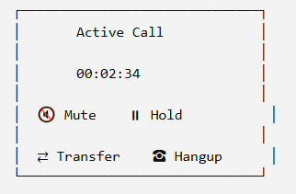

When the agent clicks Hold:
CRM
↓
phone.hold()
↓
SIP re-INVITE
↓
Asterisk
SIP.js supports hold/unhold directly.

8. Transfer
I recommend supporting two types.
Blind transfer
Customer
│
Agent
│
└──── Transfer → 2005
Attended transfer
Customer
│
Agent
│
├── Hold Customer
│
├── Call Agent 2005
│
├── Talk to 2005
│
└── Complete Transfer
This is particularly important for your call-center product.
SIP.js lists transfer support as part of its capabilities.

9. Mute
Mute should be local WebRTC media mute:
Agent microphone
↓
Mute
↓
Customer cannot hear agent
But the agent should still hear the customer.
So:
Microphone → OFF
Speaker → ON
The phone should generate:
mute
unmute
events.

10. Call recording
You mentioned:
can record calls by the phone
Laravel database
This is the preferred approach for your call center because the recording is server-side and doesn't depend on the browser remaining healthy.
Store:
call_id
agent_id
customer_number
recording_path
start_time
end_time
duration

browser recording
You can also provide:
WebRTC audio
↓
Browser MediaRecorder
↓
Upload to Laravel
But I would make this an optional feature, not the primary call recording mechanism.

11. Logo customization
Make the phone UI configurable.
For example:
AusoPhone.init({
logo: "/images/logo.png",
companyName: "Auso World",
theme: "default"
});

Or Laravel can provide:
{
"branding": {
"logo": "/storage/company/logo.png",
"company_name": "ABC Company",
"primary_color": "#...",
"show_powered_by": true
}
}
This would make your phone suitable for multi-tenant Auso Call Hub.

12. Laravel integration
I would expose a JavaScript API like:
window.AusoPhone
Example:
AusoPhone.login({
extension: "2002"
});

AusoPhone.call("0772615908");
AusoPhone.answer();
AusoPhone.hangup();
AusoPhone.hold();
AusoPhone.unhold();
AusoPhone.mute();
AusoPhone.unmute();
AusoPhone.transfer("2005");

And events:
AusoPhone.on("registered", callback);
AusoPhone.on("incoming", callback);
AusoPhone.on("ringing", callback);
AusoPhone.on("answered", callback);
AusoPhone.on("hold", callback);
AusoPhone.on("unhold", callback);
AusoPhone.on("mute", callback);

AusoPhone.on("unmute", callback);
AusoPhone.on("transfer", callback);
AusoPhone.on("hangup", callback);

This is particularly suitable for Laravel + Livewire, because Livewire can react to the JavaScript events rather than trying to control the SIP/WebRTC connection directly.

13. Agent console integration
Your desired workflow would be:
Agent Login
│
▼
Laravel Authentication
│
▼
Agent Console Loaded
│
▼
AusoPhone.initialize()
│
▼
Get SIP credentials
│
▼
Connect WSS
│
▼
REGISTER
│
▼
registered event
│
▼
Agent Ready
When agent logs out:
Agent Logout
↓
phone.unregister()
↓
WSS disconnect
↓
Asterisk endpoint becomes unavailable
↓
Laravel session closed
Asterisk's WebRTC registration model already supports browser endpoints registering through the PJSIP WebSocket transport.

14. Suggested phone component structure
I would build it as a reusable package/component:
auso-phone/
│
├── src/
│ ├── AusoPhone.js
│ ├── SIPClient.js
│ ├── CallManager.js
│ ├── RegistrationManager.js
│ ├── MediaManager.js
│ ├── TransferManager.js
│ ├── EventManager.js
│ └── RecordingManager.js
│
├── ui/
│ ├── Phone.vue
│ ├── DialPad.vue
│ ├── IncomingCall.vue
│ ├── ActiveCall.vue
│ └── TransferDialog.vue
│
└── assets/
├── css/
└── icons/
Even though your CRM is Laravel, I would keep the real-time SIP/WebRTC code independent from Laravel.
Laravel should provide:
- Agent authentication
- SIP credentials/session authorization
- Customer information
- Call records
- Agent status
- Campaign information
- Branding
- Permissions
The browser phone should handle:
- SIP
- WebRTC
- microphone
- speaker
- call state
- SIP events
- media state
Asterisk should handle:
- SIP
- RTP/SRTP
- call routing
- queues
- trunks
- recording
- transfers
- dialplan
- telephony events

My recommended specification
Requirement | Support
Chrome/Edge browser | ✅
Laravel integration | ✅
Automatic registration | ✅
Automatic unregister | ✅
Incoming CLI | ✅
Outbound calls | ✅
Answer | ✅
Auto-answer | ✅
Hold / Unhold | ✅
Mute / Unmute | ✅
Blind transfer | ✅
Attended transfer | ✅
Hangup | ✅
DTMF | ✅
Call events | ✅
Asterisk recording | ✅
Browser recording | Optional
Logo customization | ✅
Tenant branding | ✅
Agent login integration | ✅
Livewire integration | ✅
Video | Future
QUIC/WebTransport | Future

I would build this first with SIP.js + WebRTC + Asterisk PJSIP/WSS, rather than putting QUIC into the first production version. Your existing SIPml5 test proves that your Asterisk WebRTC infrastructure is already viable; the next step is turning that into a clean reusable phone component with the event API above.
One newer Asterisk option is also worth keeping in mind: Asterisk's chan_websocket can provide application/media WebSocket connectivity and supports control events such as ANSWER and HANGUP, but it is aimed at application/external-media use and is not a replacement for the normal SIP-over-WSS WebRTC phone architecture.

